MSDS670_X40_Data Visualization
Week 8 Final project
Ilse Severance
2026
Abstract
Wildfires are increasing in frequency and severity worldwide, driven by climate variability, human activity, and seasonal extremes. During this analysis, we examined over 15,500 satellite-detected wildfire hotspots across seven fire-prone regions (Australia, South Asia, Southeast Asia, Mediterranean, Sub-Saharan Africa, South America, North America) between 2024 and 2025. By integrating daily meteorological variables (temperature, humidity, wind, precipitation), we explored spatial patterns, regional intensity, temporal and seasonal trends, and atmospheric drivers of fire behavior. Our findings identify high-risk regions, seasonal peaks, and meteorological conditions correlated with fire intensity.

- Introduction
This study seeks to address the question: Where, when, and why do wildfires occur globally, and how do their intensity patterns vary across regions, seasons, and meteorological conditions? Between 2024 and 2025, satellites detected over 15,500 wildfire hotspots across seven fire-prone regions. Preliminary analysis indicates high-risk areas in Central Africa, India, Southeast Asia, and northern Australia, moderate activity in the U.S., southern Africa, and parts of South America, and lower activity in Europe, northern Asia, and North America. By examining these spatial, temporal, and environmental patterns, the study aims to inform national level assessments, seasonal planning, and meteorological risk modeling for more effective wildfire management.
- Methodology
  - Data Collection
All data in this study were collected from Kaggle.
- Fire hotspot data were derived from satellite sensors (MODIS and VIIRS).
- Meteorological variables include maximum temperature (°C), wind speed (km/h), precipitation (mm), and relative humidity (%).
- Spatial coverage: Seven fire prone regions across 35 countries, spanning January 2024 to December 2025
2.3 Analysis Techniques
- Global Fire Density Heatmap: We aim to visualize the spatial concentration of fire intensity worldwide.
- Top 10 Country: We aim to compare fire activity at the national level and highlight the most affected countries.
- Temporal and Seasonal Heatmaps: We aim to identify trends in fire activity across months and seasons.
- KDE Distributions of Meteorological Variables: We aim to examine how temperature, humidity, wind, and precipitation influence fire intensity.
- Global Wildfire Hotspot Distribution
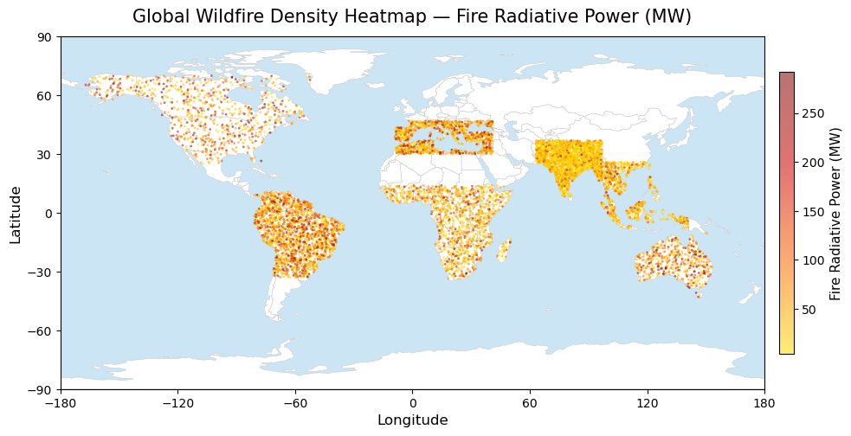
The global FRP heatmap (Figure 1), highlights where fire intensity, measured by Fire Radiative Power (FRP), is most concentrated. High intensity hotspots appear in Central Africa, India, Southeast Asia, and northern Australia, while moderate activity spans the U.S., Southern Africa, and parts of South America. Low intensity zones in Europe, northern Asia, and North America reflect cooler climates, higher moisture, and stronger fire management. This visualization emphasizes global risk concentration and priority regions.

Figure 1. Global Wildfire Density Heatmap

- Top 10 Countries by Total Wildfire Radiative Power
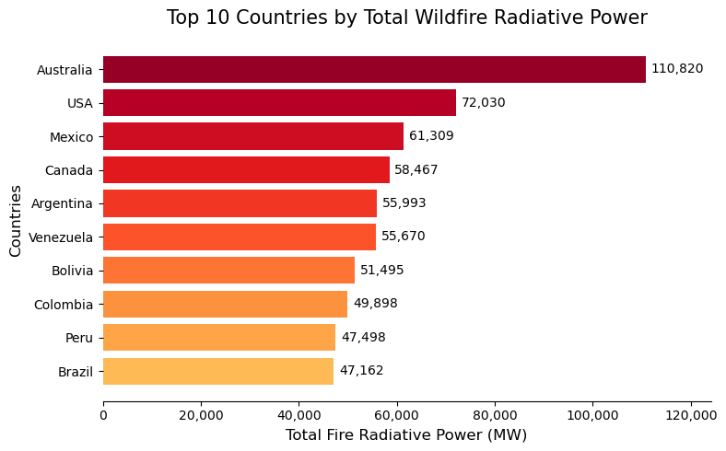
The Top 10 countries chart (Figure 2) rank nations by total FRP, highlighting Australia and the U.S. as the most exposed. Mid-tier countries including Mexico, Canada, Argentina, Venezuela, and Bolivia show sustained fire activity, while Colombia, Peru, and Brazil emerge as hotspots due to agricultural expansion and deforestation. These patterns guide resource allocation, risk mitigation, and policy interventions at the national level.
Figure 2. Top 10 Countries by Total Wildfire Radiative Power.
- Seasonal Patterns of Monthly Fire Detections by Region
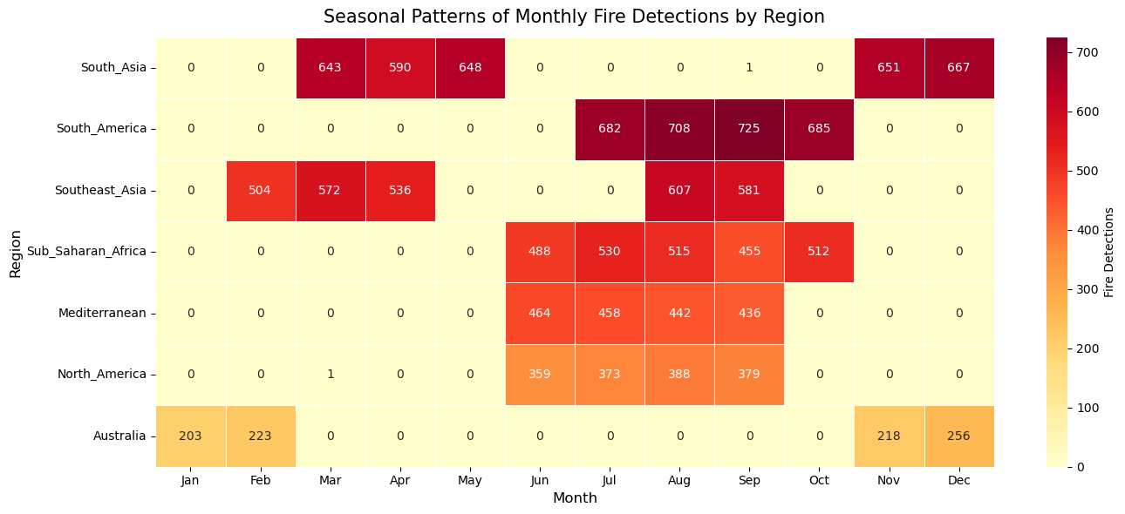
As shown in the monthly fire detection heatmap Figure 3, there are seasonal peaks that follow climate patterns in each hemisphere. Fire activity increases during the Northern Hemisphere summer in regions such as the Mediterranean and North America, and during the Southern Hemisphere summer in areas like Australia and South America. The chart helps identify months with the highest fire risk, allowing for earlier monitoring and response, and highlighting differences in the timing and length of fire seasons across regions, which can support operational planning and disaster preparedness.
Figure 3. Seasonal Patterns of Monthly Fire Detections by Region Heatmap
- Regional Variation in Average Seasonal Wildfire Risk
The heatmap (Figure 4) shows regional and seasonal variation in global fire risk, showing that regions like Australia and North America experience elevated risk during spring and summer, while South America and Sub-Saharan Africa maintain moderately high risk throughout the year. Areas like South Asia and the Mediterranean demonstrate seasonal peaks tied to hot, dry summers, whereas Southeast Asia shows more stable risk across seasons. Because these patterns emerge from aggregating monthly fire data into seasonal categories, the visualization highlights when each region faces its most critical exposure, presenting that tropical and subtropical zones sustain relatively consistent fire activity while temperate regions exhibit distinct seasonal peaks.

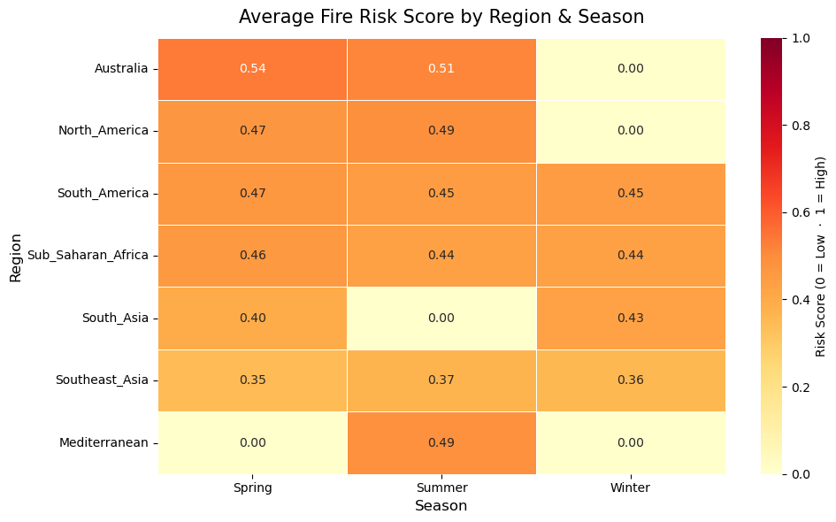

Figure 4. Average Fire Risk Score by Region & Season
- Atmospheric Variable Distributions by Fire Intensity
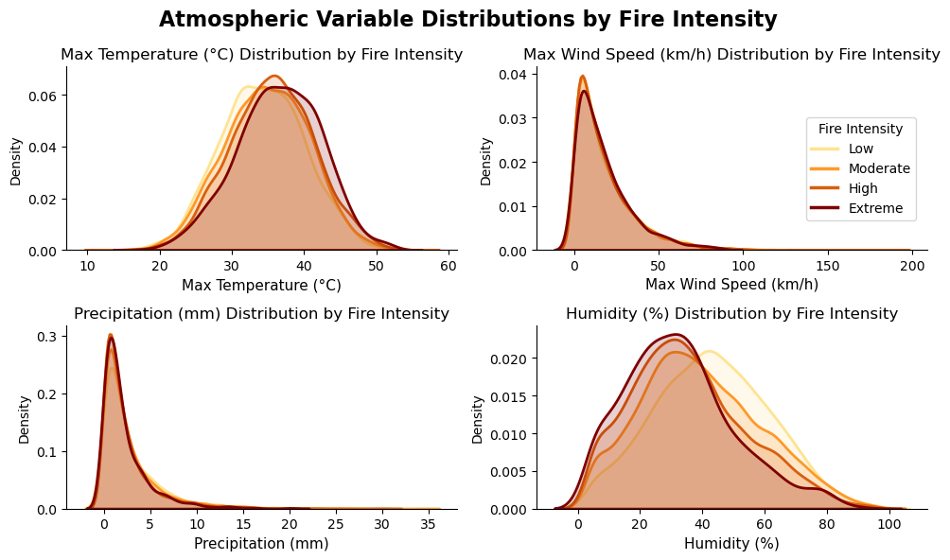
KDE distribution plots illustrate how temperature, humidity, wind, and precipitation influence wildfire severity. High-intensity fires are strongly associated with hot, dry conditions, with wind acting as a compounding factor, while precipitation helps suppress fires but is less discriminative without temporal context. These observed shifts in meteorological variables underscore their importance for fire intensity classification, predictive modeling, risk scoring, and early warning systems, transforming environmental observations into actionable insights.
Figure 5. Atmospheric Variable Distributions by Fire Intensity
- Conclusions
During this analysis, we found that wildfire risk is highest in tropical and subtropical regions, with seasonal peaks highlighting critical hotspots for operations and resource allocation. Australia, the U.S., Central Africa, India, and Southeast Asia experienced the most severe fire activity, while Europe, northern Asia, and North America had lower exposure.
At the national level, Australia and the U.S. lead in fire intensity, with South American countries emerging as growing hotspots due to agricultural expansion and deforestation.
Based on the data the key meteorological drivers are high temperatures, low humidity, strong winds, and limited precipitation. They influence fire severity, offering predictive insights for risk management, early warning systems, and strategic deployment of firefighting resources.
By combining spatial, seasonal, and environmental data, organizations can make data driven decisions to mitigate wildfire risk, optimize operational planning, and allocate resources more effectively.

References:
Shah, A. (2024). Wildfire Risk Dataset 2024–2025: 7 regions [Data set]. Kaggle. Wildfire Risk Dataset 2024-2025 | 7 Regions

